
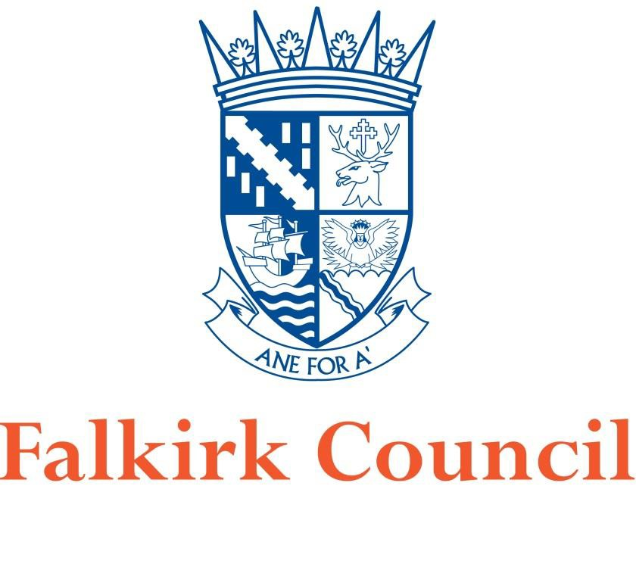
Proposal for Revocation of Banknock Air Quality Management Area (AQMA)
In fulfillment of Part IV of the Environment Act 1995 Local Air Quality Management
2020

Local Authority Officer | Author: John Millar (Air Quality Specialist) Reviewed by: David Gray (Env. Protection Co-ordinator) and  Graeme Webster (Env. Health and Trading Standards Manager)
Department | Environmental Health,  Development Services
Address | Abbotsford House, David’s Loan, Falkirk, FK2 7YZ
Telephone | 01324 504873
E-mail | JohnA.Millar@falkirk.gov.uk
Report Ref: | Revocation Proposal, Banknock AQMA
Status | Final
Date | 07/02/2020

Table of Contents
- Introduction… 4
- Air Quality Management Area – Particulate Material 5
- Local Quarry Operations 5
- Monitoring Equipment 6
- Monitoring Data 7
- Conclusion… 8
- References 9
- Figures 10

Introduction
The Environment Act 1995 (HM Government, 1995) required the preparation of a national air quality strategy setting Air Quality Objectives (AQOs) for specified pollutants and outlining measures to be adopted by local authorities through the system of Local Air Quality Management (LAQM) and by others to work in pursuit of the achievement of these objectives. A National Air Quality Strategy was published in 1997 and subsequently reviewed and revised in 2000, and an addendum to the Strategy published in 2002. The current Strategy¹ was published in July 2007 (Welsh Assembly Government, Scottish Executive, Department for Environment, Department for Environment Food and Rural Affairs, 2007).

The AQOs which are relevant to LAQM in Scotland and have been set into regulations, namely the Air Quality (Scotland) Regulations 2000², the Air Quality (Scotland) Amendment Regulations 2002³ and the Air Quality (Scotland) Amendment Regulations 2016⁴ (Scottish Government, 2016).

Falkirk Council has a responsibility to comply with the above regulations when managing local air quality. The Council completes its LAQM duties by managing an extensive air quality monitoring network, assessing results and reporting on areas of existing or anticipated poor air quality - declared via Air Quality Management Areas (AQMA).

One of the areas identified which was subject to historic poor air quality was Banknock, situated on Falkirk Council’s eastern boundary (adjacent to the North Lanarkshire local authority area). This is shown in section 8. Figures - Map 1 Banknock Area within Falkirk Council Boundary.

- Air Quality Management Area – Particulate Material (24-hour and Annual Mean)

The Council’s Detailed Assessment⁵ of Particulate Material (PM₁₀) in Banknock (published in December 2010) detailed a high volume of National Air Quality Objective (NAQS) exceedances for PM₁₀ (24-hour and annual mean). This Detailed Assessment led to a declaration of the AQMA on 18th August 2011 following extensive consultation. Table 1 displays the pollutant of relevance for this AQMA revocation proposal, and the Scottish AQSs which must be met for the protection of human health.

Table 1 – AQSs for Scotland applicable for this proposal

Pollutant | Concentration | Measured as
Human Receptors
Particulate material (PM₁₀) | 50 µg/m³, not to be exceeded more than 7 times a year | 24-hour mean
Particulate material (PM₁₀) | 18 µg/m³ | Annual Mean

The Detailed Assessment identified that local quarry operations combined with associated site and local road traffic had been a significant source of dust in this area. The AQMA within Banknock is shown in section 8. Figures – Map 2 – Banknock AQMA.

Local Quarry Operations

There has been an operational quarry at Cowdenhill, Banknock since as early as 1926, and this was operated by Stirlingshire County Council in the 1940's. The site has since been used intermittently for quarrying, with the Skene Group operating the quarry under modern working conditions from 2000 until July 2011. Falkirk Council Application F/99/0026 remains a live permission, allowing for the extraction of aggregate material from the site until 2024.

A nearby quarry called Tomfyne has been planned within the North Lanarkshire area which is awaiting approval. Falkirk Council is a statutory consultee on this.

The above quarries within the Banknock area are shown in section 8. Figures – Map 4 - Locations of Cowdenhill and Tomfyne Quarries in Banknock Area.

At present, there are no plans to extract further aggregate materials from these quarries.

Falkirk Council

Monitoring Equipment
The following air quality monitoring equipment has been deployed in the Banknock area since 2009 until present: Table 2: Banknock AQMA Air Quality Monitoring Stations and Equipment

AQ Monitoring Site ID: | Banknock 1 | Banknock 2 | Banknock 3
Site Type: | Roadside (Automatic) | Roadside (Automatic) | Rural (Automatic)
Address: | Coneypark Place | Kilsyth Road (A803), FK4 1TZ | Bracken View, Coneypark Crescent, FK4 1TR
OS Grid Ref (E / N): | 277348 / 679037 | 277247 / 679027 | 277168 / 679254
Equipment: | Turnkey Osiris - TNO2777 | R&P 1400 TEOM (from 06/12/2012 - 02/02/2015) | Turnkey Osiris - TNO2777
Equipment: | Turnkey Osiris - TNO2777 | Palas FIDAS 200 (from 02/02/15 until present) | Turnkey Osiris - TNO2777
Monitoring Technique | Optical, Light scattering | TEOM: Gravimetric, FIDAS: Optical, Light scattering | Optical, Light scattering
Date Installed: | 22/09/2009 | 16/11/2012 | 29/07/2013
Date Removed: | 29/07/2013 | Still operational at this roadside location | Still operational at this rural location

The location of the Banknock 2 and 3 automatic monitoring stations can be shown in section 8. Figures - Map 3 - Monitoring Station Locations.
The current monitoring stations and equipment for Banknock 2 and 3 stations above can be shown in Appendix 1 – Photos.

Monitoring Data

Falkirk Council monitors PM₁₀ and other pollutants at several locations throughout the Council area using both automatic and passive sampling methods. The automatic monitoring data displayed below has been fully ratified in accordance with the Scottish Air Quality Database QA/QC Process⁶.

The Council currently operates two automatic monitoring stations located within the Banknock AQMA – these are Banknock 2 and 3 (as detailed in Table 2).

The PM₁₀ (24 hour and annual mean) monitoring data (as extracted from the 2019 Falkirk Council APR⁷) are displayed in Tables 3 and 4.

Table 3: Measured PM₁₀ 24-Hour Mean Results 2014 – 2018

Site ID | Site Type | Valid Data Capture for Monitoring Period (%)  (1) | Valid Data Capture 2018 (%)  (2) | PM₁₀ 24-Hour Means >50µg/m³ ⁽³⁾
 |  |  |  | 2014 | 2015 | 2016 | 2017 | 2018
A13 | Banknock 2 | 100 | 100 | 3 | 4 | n/a | 7 | 0
A14 | Banknock 3 | 80 | 80 | 0 (24) | 1 | 3 | 0 | 2 (10)
Notes: Exceedances of the PM₁₀ 24-hour mean objective (50µg/m³ not to be exceeded more than 7 times/year) are shown in bold.
  - Data capture for the monitoring period, in cases where monitoring was only carried out for part of the year.
  - Data capture for the full calendar year (e.g. if monitoring was carried out for 6 months, the maximum data capture for the full calendar year is 50%).
  - If the period of valid data is less than 85%, the 98.1st percentile of 24-hour means is provided in brackets.

Table 4: Measured PM₁₀ Annual Mean Results 2014 – 2018

Site ID | Site Type | Valid Data Capture for Monitoring Period (%)  (1) | Valid Data Capture 2018 (%)  (2) | PM₁₀ Annual Mean Concentration (µg/m³)
 |  |  |  | 2014 | 2015 | 2016 | 2017 | 2018
A13 | Banknock 2 | 99 | 99 | 13.2 | 11 | 11 | 13 | 11
A14 | Banknock 3 | 80 | 80 | 15 | 8.2 | n/a | 7 | 6.9
Notes: Exceedances of the PM₁₀ annual mean objective of 18µg/m³ are shown in bold.
    - Data capture for the monitoring period, in cases where monitoring was only carried out for part of the year.
    - Data capture for the full calendar year (e.g. if monitoring was carried out for 6 months, the maximum data capture for the full calendar year is 50%).
    - All means have been “annualised” as per LAQM.TG (16); valid data capture for the full calendar year is less than 75%.

Conclusion

The Banknock AQMA was declared on the 18th August 2011 following a high volume of National Air Quality Objective (NAQS) exceedances for PM₁₀ (24-hour and annual mean). Since the AQMA was declared, measured concentrations (using automatic, referenced monitoring methods) of PM₁₀ have complied with the NAQS objectives consistently over the past five years (since 2014).
A previous review and assessment report has identified that local quarry operations combined with associated site and local road traffic had been a significant source of dust in this area.
It is understood that there are no current plans to operate any aggregate quarries within the Banknock area.

As a result of the ongoing automatic air quality monitoring within the Banknock AQMA the Council has demonstrated that the 24-hour and annual mean concentrations of PM₁₀ complies with the NAQS objectives. It is understood that the reduction in quarry operations in this area has led to a reduction in overall PM₁₀ concentrations and thus compliance with the NAQS objectives.

As stated within the Air Quality in Scotland (LAQM) website in relation to AQMA Revocation: ‘Where a local authority feels that it has sufficient evidence to justify the need to amend/revoke an AQMA at any time, it should submit that evidence to the Scottish Government for appraisal. For those authorities that have continuous monitoring, the Scottish Government would expect them to keep the AQMA under regular review, and to take action where necessary, rather than await the next round of reviews and assessments.’

Falkirk Council will continue to have a PM₁₀ monitoring capability within this area until 2024 when the live planning consent of the Cowdenhill quarry expires. It is anticipated that the automatic monitoring equipment within the Banknock area could be used to focus on other areas of poor air quality within the region.

Falkirk Council is requesting the permission of the Scottish Government and Scottish Environment Protection Agency (SEPA) to revoke the Banknock AQMA. Pending permission approval, Falkirk Council will notify all other statutory consultees and publicise the revocation through local / social media, so the public and local businesses are fully aware of the situation.

References

- The Air Quality Strategy for England, Scotland, Wales and Northern Ireland (Volume 1, July 2007, Department for Environment, Food and Rural Affairs in partnership with the Scottish Executive, Welsh Assembly Government and Department of the Environment Norther Ireland)
- The Air Quality (Scotland) Regulations 2000 (31st March 2000, The Scottish Government)
- The Air Quality (Scotland) Amendment Regulations 2002 (11th June 2002, The Scottish Government)
- The Air Quality (Scotland) Amendment Regulations 2016 (1st April 2016, The Scottish Government)

- Detailed Assessment of PM₁₀ in Banknock (December 2010, Falkirk Council)

- The Scottish Air Quality Database QA/QC Process (28th March 2012, AEA Ricardo / The Scottish Government)

- Annual Progress Report (July 2019, Falkirk Council)

Figures - Map 1 - Banknock Area within Falkirk Council Boundary
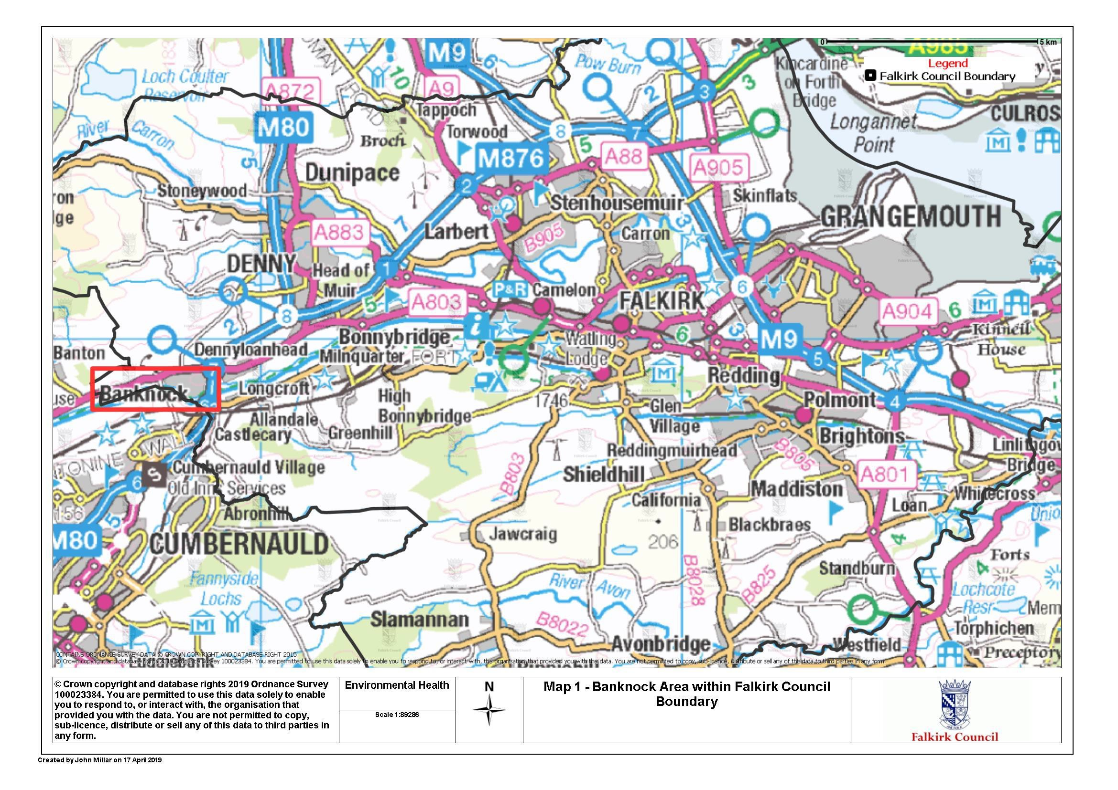

Map 2 - Banknock AQMA
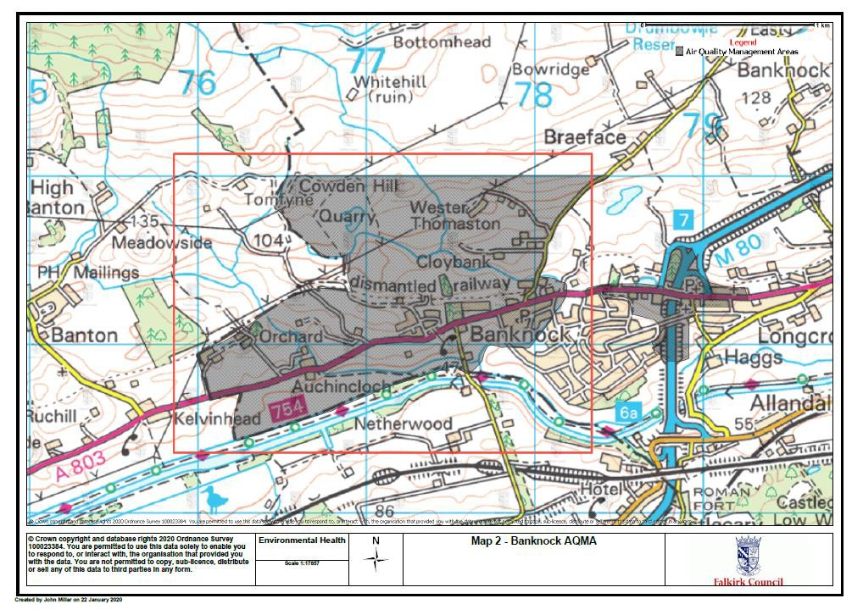

Map 3 - Monitoring Station Locations
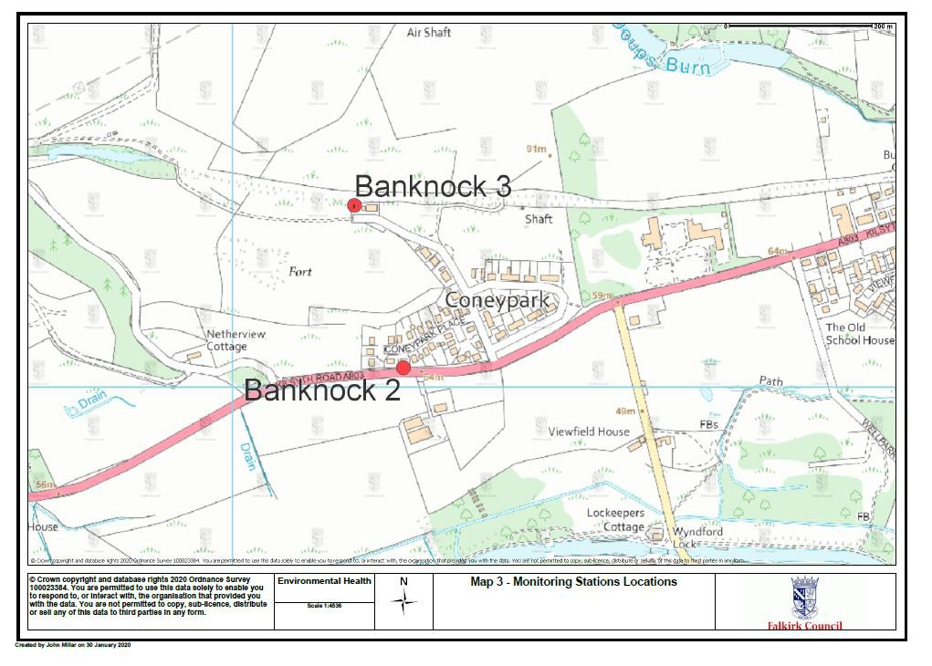

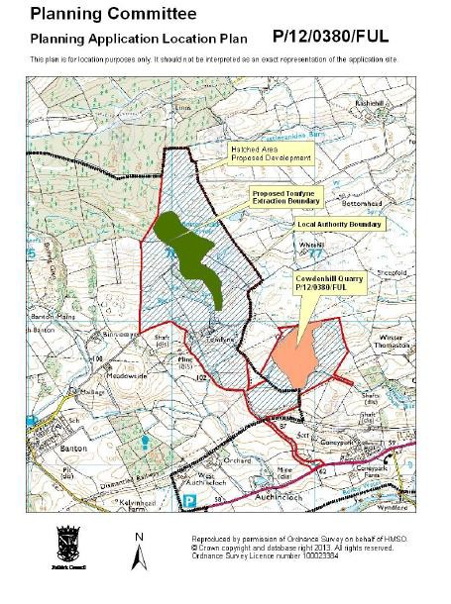
Falkirk Council

Map 4 – Locations of Cowdenhill and Tomfyne Quarries in Banknock Area

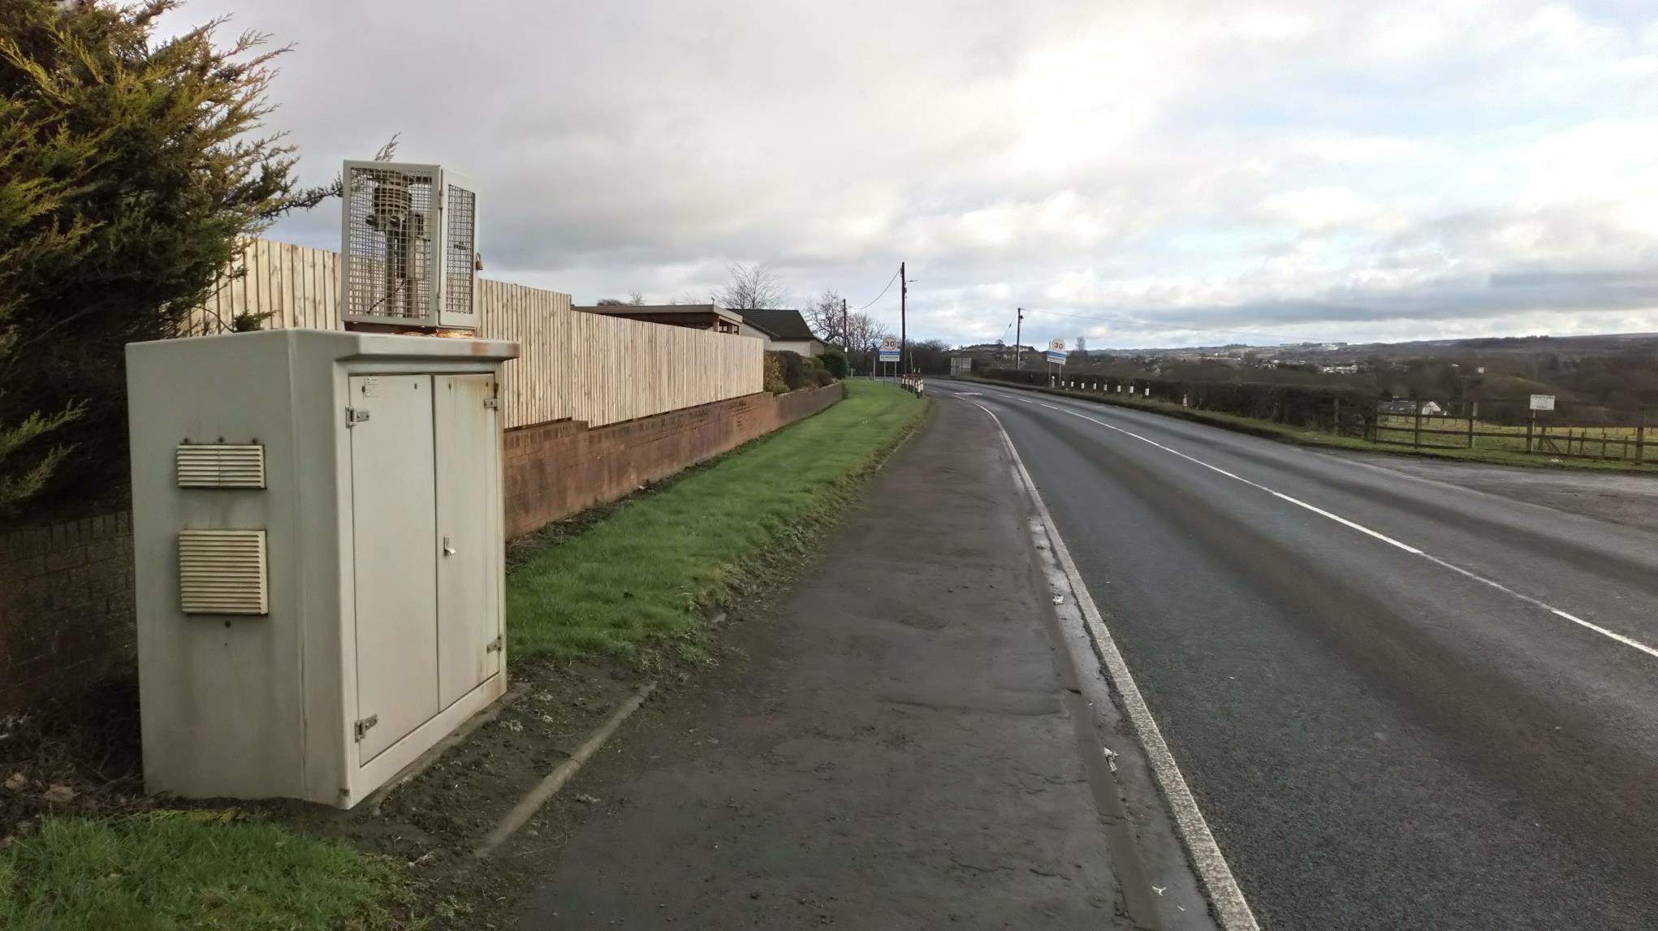
Falkirk Council
Appendix 1: Photo 1 – Banknock 2 Automatic Roadside Station

Falkirk Council

Photo 2 – Banknock 2 Automatic Roadside Station
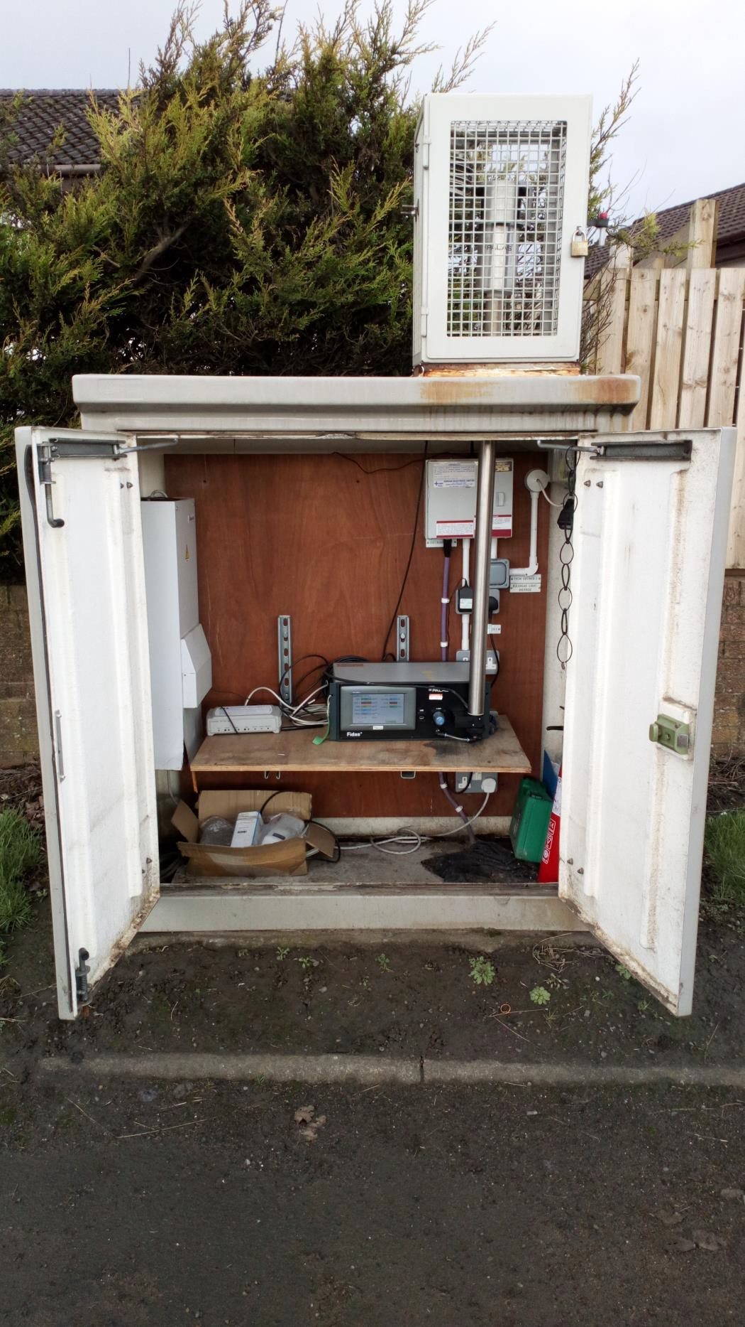

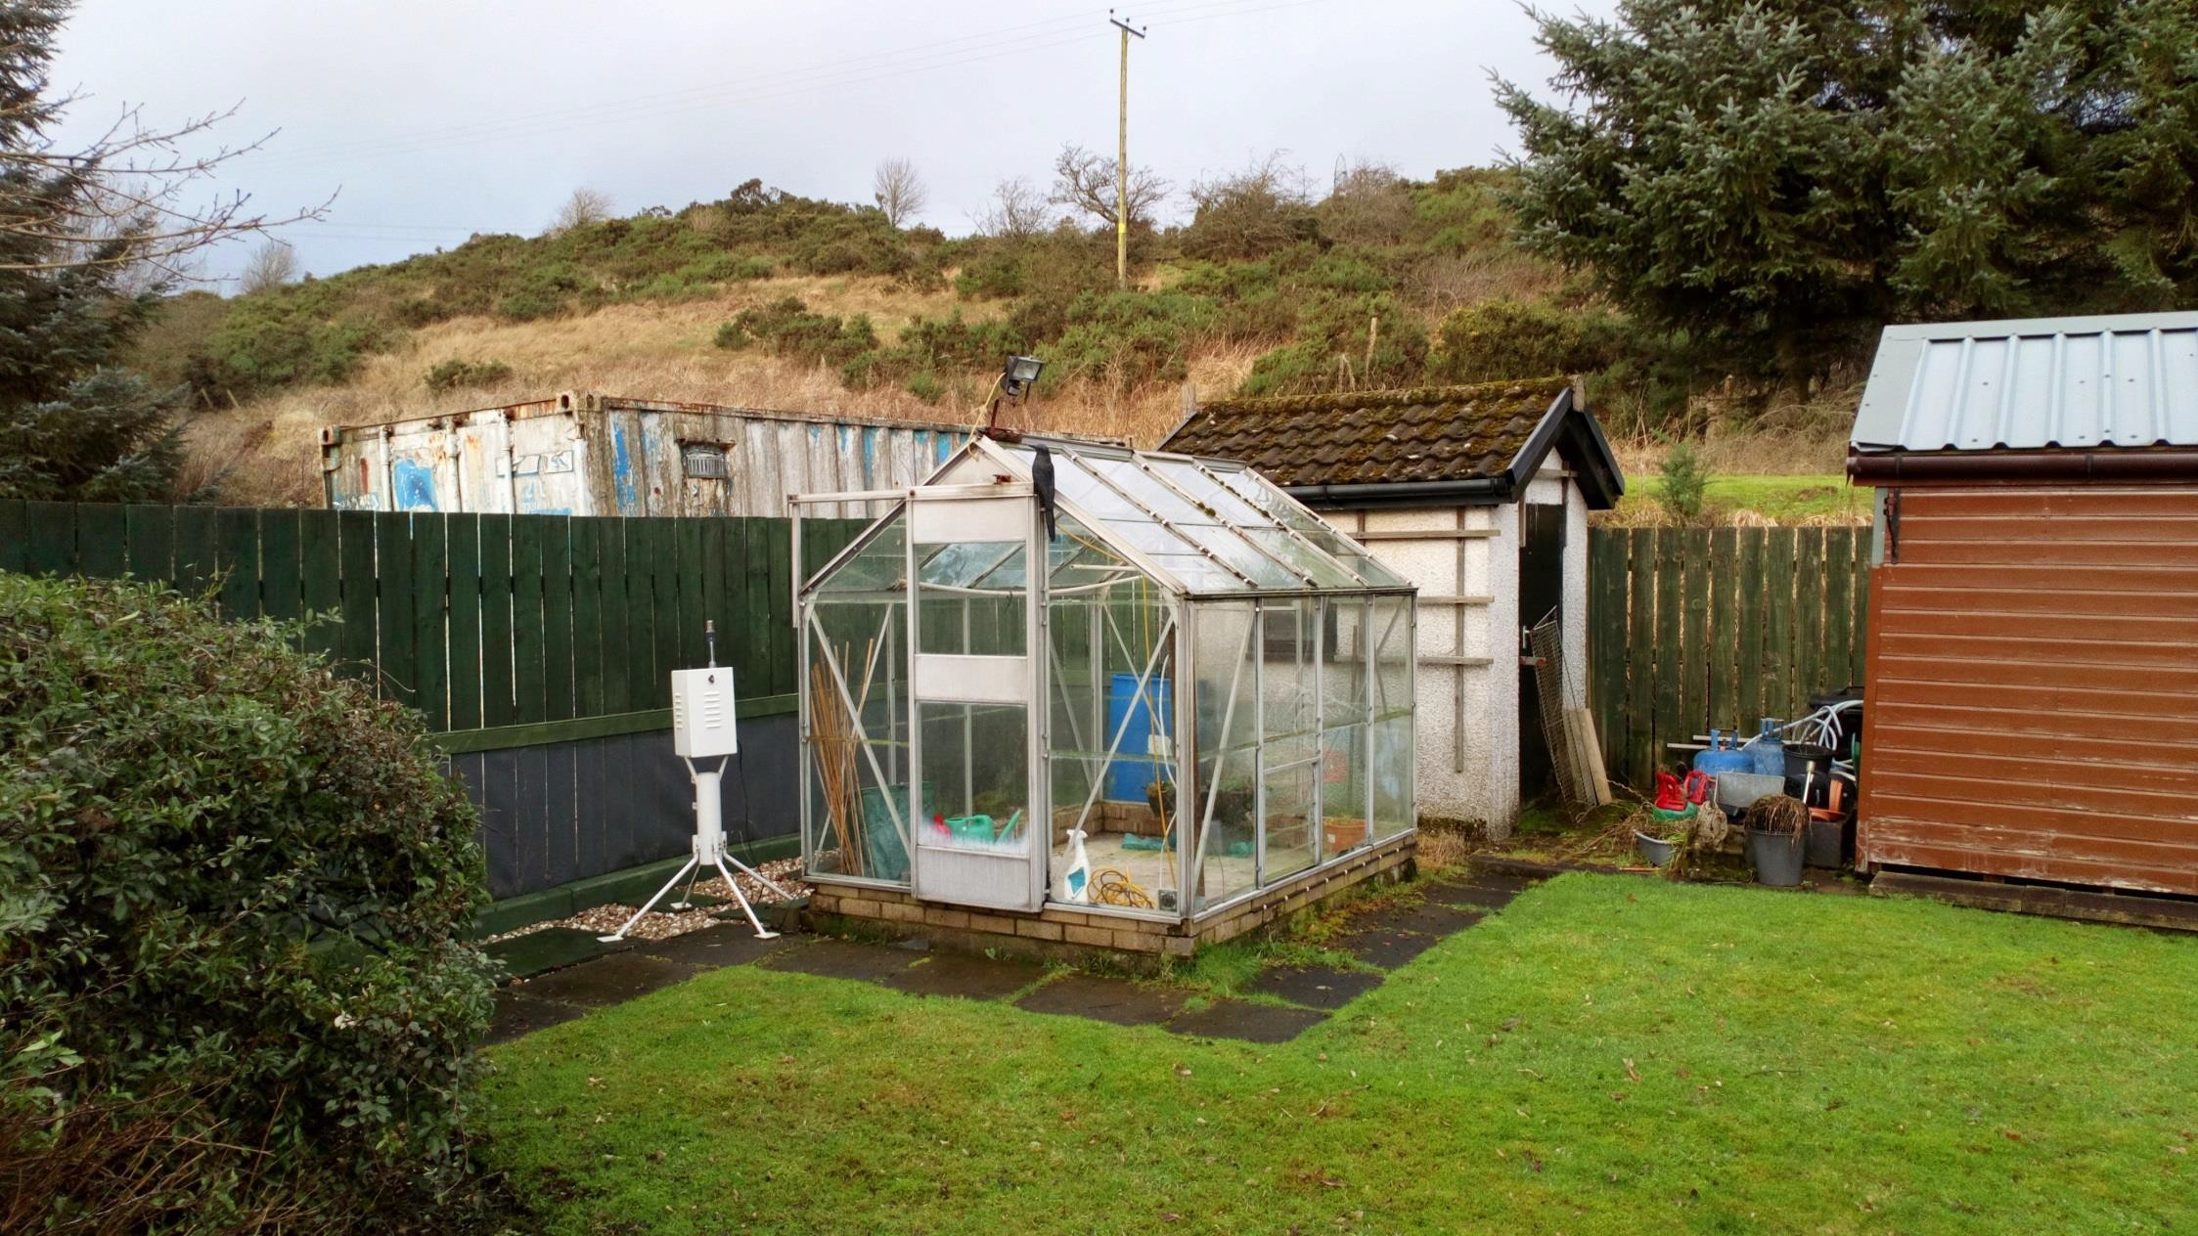
Falkirk Council
Photo 3 – Banknock 3 Automatic Rural Station

Falkirk Council

Photo 4 – Banknock 3 Automatic Rural Station
